1.Created a Windows instance and installed webserver on it.

Windows server Public IP: 52.3.250.76

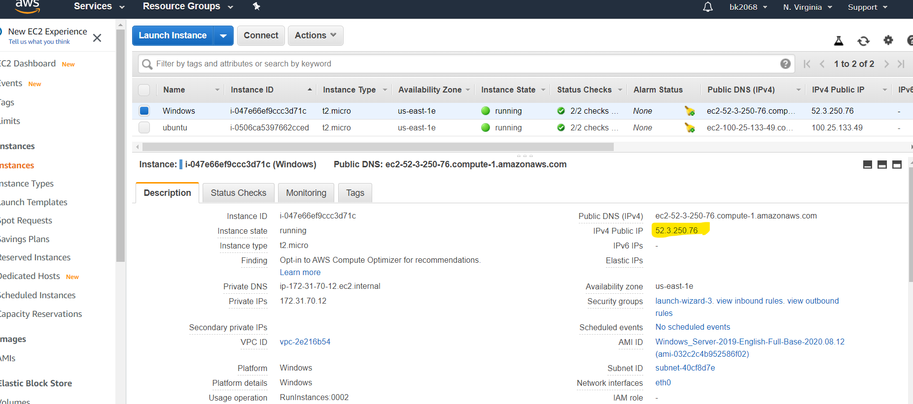

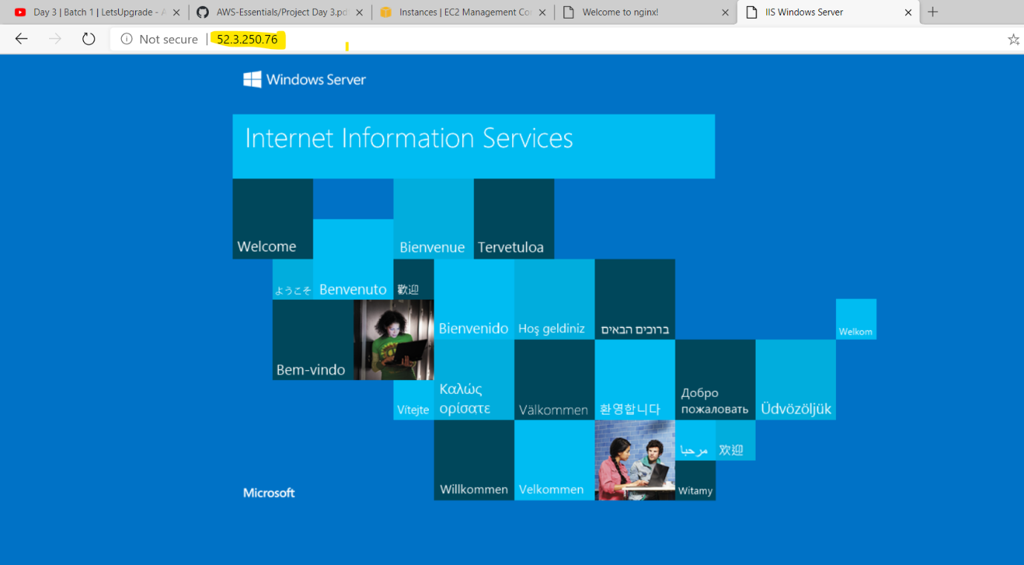

2. Created ubuntu instance and installed nginx on it .

Ubuntu server public IP: 100.25.133.49

